Documentation for running an project on the colud based ecosystem

==> For kaggle uploading the file or simple file(.csv) upload
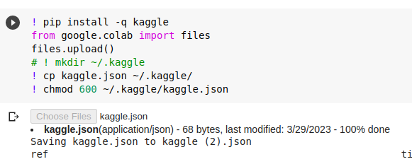
==> For selecting the data set
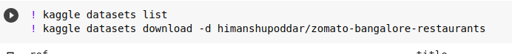
==> For installing the different libraries
